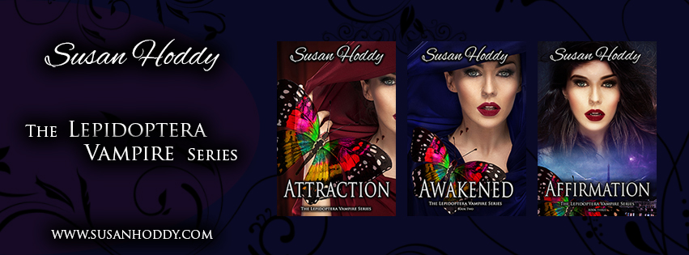

Hello and welcome to my August Newsletter.

Unbelievable, another month has come and gone. Where does the time go…

I am excited to announce that I have now released and self-published Attraction and Awakened, which are the first two books in a series of five, that I will be writing for The Lepidoptera Vampire Series and they are available in E-Book and Paperback.

You can now buy ‘Attraction’ atDymocks, Collins Booksellers, Rockingham Books, Viva Books, Crow Books and all good bookshops. To get it right now, here are some links:

**Available from**

[**Amazon**](https://www.amazon.com.au/s/ref=nb_sb_noss?url=node%3D2496751051&field-keywords=susan+hoddy) **– E-Book**

[**Amazon**](https://www.amazon.com/Attraction-Lepidoptera-Ms-Susan-Hoddy/dp/0995413428/ref=tmm_pap_swatch_0?_encoding=UTF8&qid=&sr=) **- Paperback**

[**Booktopia**](http://www.booktopia.com.au/search.ep?keywords=susan+hoddy&productType=917504) **– Paperback & E-Book**

[**Susan Hoddy Website**](http://susanhoddy.com/books/) **– E-Book & Paperback**

[**Kobo**](https://www.kobo.com/au/en/search?Query=susan+hoddy) **– E-Book**

[**Smashwords**](https://www.smashwords.com/books/view/700682) **– E-Book**

[**Barnes & Noble**](http://www.barnesandnoble.com/s/susan+hoddy?_requestid=134529) **– E-Book & Paperback**

You can now buy *‘*Awakened’ atDymocks, Collins Booksellers, Rockingham Books, Viva Books, Crow Books and all good bookshops. To get it right now, here are some links:

**Available from**

[**Amazon – E-Book**](https://www.amazon.com.au/d/Awakened-Lepidoptera-Vampire-Vampires-Book-ebook/B07211VFYB/ref=sr_1_1?ie=UTF8&qid=1499053001&sr=8-1&keywords=susan+hoddy)

[**Amazon - Paperback**](https://www.amazon.com/Awakened-Lepidoptera-Vampire-Susan-Hoddy/dp/0995413479/ref=tmm_pap_swatch_0?_encoding=UTF8&qid=1499053223&sr=8-1)

[**Susan Hoddy Website – E-Book & Paperback**](http://susanhoddy.com/books/)

[**Kobo – E-Book**](https://www.kobo.com/au/en/ebook/awakened-38)

[**Smashwords – E-Book**](https://www.smashwords.com/books/view/727432)

[**Barnes & Noble – E-Book & Paperback**](https://www.barnesandnoble.com/w/awakened-susan-hoddy/1126488290?ean=9780995413474)

**If you are after a signed copy of my books, I do still have some available. Please fill in the** [**contact us**](http://susanhoddy.com/contact-us-2/) **form on my website** [**susanhoddy.com**](http://susanhoddy.com/books/) **. Anyone who purchases a signed copy from me will receive a free book mark as well.**

I would like to say a Big Thank you to Chris, Karen & Erin at [Viva Books](https://www.vivabooks.net/) Busselton for stocking my two books Attraction & Awakened in their store. Well worth a visit to this store in Busselton. Staff are very friendly and welcoming. They have an excellent range of books, especially in the YA (Young Adult) genre in their store. Next time you are over that way, pop in, you won’t be disappointed.

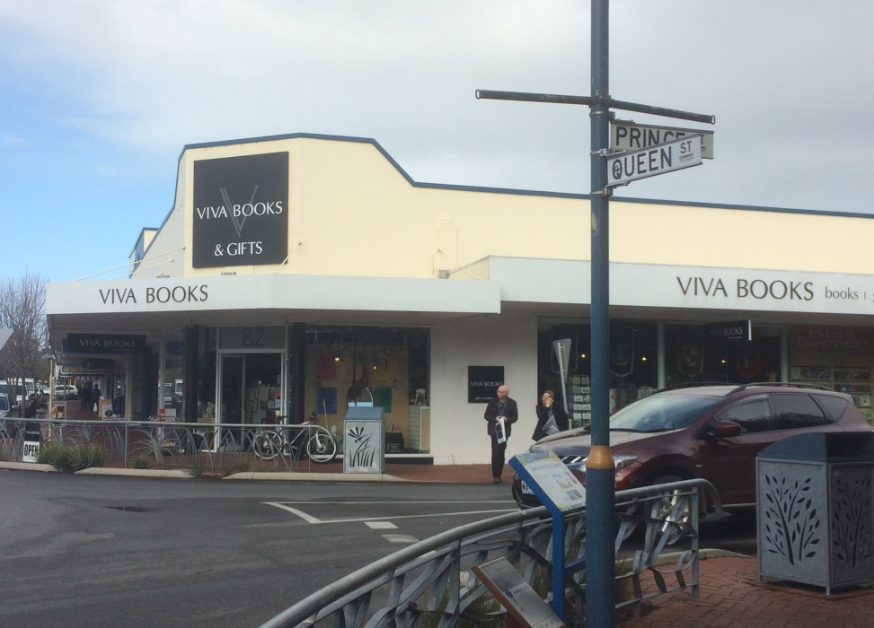

**It’s funny how when I am sick that my mind seems to have writers block.**

Currently, I am only at 55,248 words into the third book of the Lepidoptera Vampire Series. Continuing to write more each day. I would like to have had it ready for editing by end of July, but because I have been sick with a head cold, I wasn’t able to finish it. Now that I am well again I am hoping to have it finished for editing by end of August, as I want to publish the third book in the series of five by November 2017.

What do you think of the third book cover?

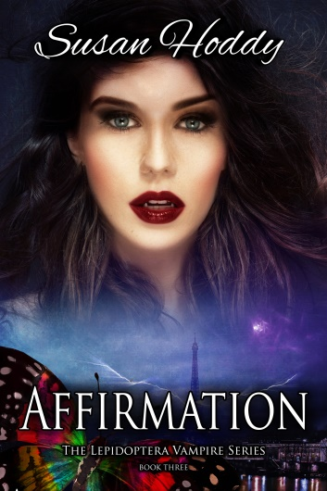

Feedback is good for authors – Is there something that you would like to see happen in the next book, or anything you don’t like or should be different in the first two books. Let me know, because I am always willing to listen to new ideas. Please log onto my website [susanhoddy.com](http://susanhoddy.com/books/) and fill in the [contact us](http://susanhoddy.com/contact-us-2/) form.

Have you ever had to write a manuscript , e-mail, power point presentation, policy & procedures, or even a letter to a friend/family member and you just cant seem to find the right word? Well here are a few words that may help you, instead of using the word **‘Very’**.

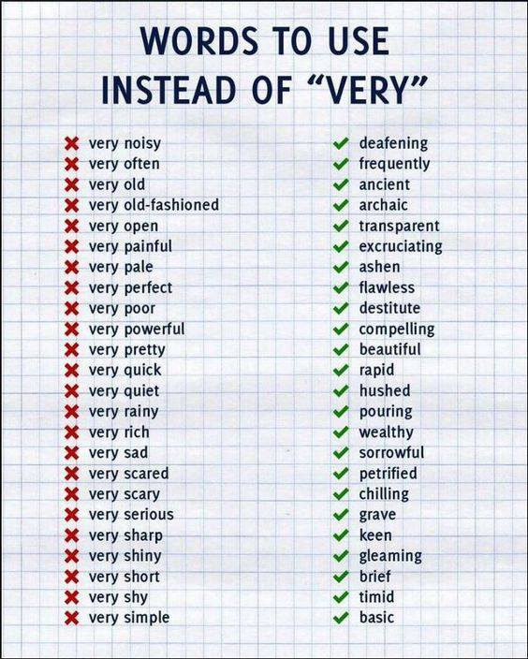

**EXTREMELY GRATEFUL FOR REVIEWS ON AMAZON OR GOODREADS.**

A big thank you to the lovely person who left a great review on Amazon for me on my first book Attraction - The Lepidoptera Vampire Series.

Top customer reviews

5.0 out of 5 stars.

By Amazon Customer on July 4, 2017

Format: Kindle Edition

I loved this book- it was so easy to read and just what I needed while I was on holidays. I instantly felt the characters come to life and I was sad when I came to the last page. So much so that I ran out and brought the second book "Awakening" the moment I got back to Perth. Now I can't wait to read this one and then hopefully buy the third book. Susan is a fantastic author and I am sure lots of people will enjoy reading her books.

Well it looks like Winter has finally set in, here in Perth Western Australia. Besides getting your flu shots and rugging up, here are a few tips for keeping healthy.

**4 Daily Health Habits**



Enhancing your health doesn’t have to mean spending hours each day at the gym or eating like a rabbit. Here are four daily tips to remember:

**Drink plenty of pure water.** Put the kibosh on soda consumption and opt to drink at least 8 glasses of water a day.

**Tweak what you eat.** Give each meal an upgrade by swapping out a food for one that’s more nutrient-dense. For example, exchange iceberg lettuce for spinach, kale or arugula.

**Get sufficient sleep.** Adults should aim to get 7-8 hours of quality sleep a night. Sleep plays a critical role in maintaining excellent health.

**Move more.** As sitting has been called “the new smoking,” it’s important to incorporate plenty of movement into your day. Simply walking more can pay health dividends.

**Helping Business’s Getting Recognition -**  In recognition of business’s out there that are making a difference in the world, I would like to promote the following companies and to say a big thank you for all your lovely products:-

[Sandra Orr - Advocate for Inner Origin](https://www.facebook.com/HealthyNowLiving/). Healthy Now Living – (Inner Origin), is a Wellness Revolution in Health and Wellness products. It’s your virtual community market place, and a one stop online shop, where transparency is key, and truth on label to product certification that goes as deep as the country of origin for every ingredient. For more information on the products that Sandra is promoting and selling, check out the [Healthy Now Living website](http://www.innerorigin.com/advocate/HealthyNowLiving). Or if you would like to speak with Sandra about any of her products she is only too happy for you to e-mail her on [sandrahealthyliving@gmail.com](mailto:sandrahealthyliving@gmail.com)

[**Michelle Chia – Independent Younique Presenter**](https://www.youniqueproducts.com/michellesflawlessfancies)**.** Younique is a beautiful range of cosmetics, makeup and skin care products sold internationally which can uplift, empower, validate and ultimately build self-esteem in women, with their high quality products that encourage both inner and outer beauty. For more information on the products that Michelle is promoting and selling, check out the [Younique website.](https://www.youniqueproducts.com/michellesflawlessfancies) Or if you would like to speak with Michelle about any of her products she is only too happy for you to e-mail her on [michellechia@bigpond.com](mailto:michellechia@bigpond.com)

Have you ever been onto the Goodreads website? It’s a website where you can read & review literally thousands of books. Below is a link for you. Enjoy…

[http://www.MyAuthorBiz.com/accounts/laraadrian/images/goodreads-add-badge.png?v=1402397218332](https://www.goodreads.com/book/show)

|  |  |  |  |  |  |  |  |  |  |  |  |  |  |  |  |  |
| --- | --- | --- | --- | --- | --- | --- | --- | --- | --- | --- | --- | --- | --- | --- | --- | --- |
| **Ever thought of leaving a review?**  If you love Susan Hoddy books, would you like to tell people about them? Visit [**Amazon**](https://www.amazon.com/s/ref=nb_sb_noss_1?url=search-alias%3Ddigital-text&field-keywords=susan+hoddy)or[**Goodreads**](http://www.goodreads.com/book/show/34307314-attraction) and write review/comment about my books. Positive or Negative. All opinions welcomed.  Susan Hoddy is an Australian, American and French young-adult fiction writer, best known for her Lepidoptera Vampire Series. Susan was born in Perth, Western Australia in 1966, and enjoys a good chinwag with family and friends, cups of tea, day-dreaming and writing. After acquiring her novel writing diploma from the Australian College of Journalism, she continues to create worlds where fantasy and romance exists, with her books. Keep an eye on her website [susanhoddy.com](http://susanhoddy.com) for more information about when the next book is coming out in November 2017.    **Free goodies for readers!**  C:\Users\hoddy\AppData\Local\Packages\Microsoft.Windows.Photos_8wekyb3d8bbwe\TempState\ShareCache\20170523_101608.jpg  I love to spoil my readers with bookmarks - free for the asking. Just send your request along with your **name, mailing address, and email address** to my website [susanhoddy.com](http://susanhoddy.com/contact-us-2/) and fill in the [Contact Us](http://susanhoddy.com/contact-us-2/) form.  Image may contain: 1 person, meme and text  **If you enjoyed reading my newsletter, please forward my e-mail to your work colleges, family and friends. I am only too happy if they would like to be added to my mailing list each month. Spread the word…**  **Connect with me!**   |  |  |  |  |  |  |  |  |  |  |  |  |  |  |  |  | | --- | --- | --- | --- | --- | --- | --- | --- | --- | --- | --- | --- | --- | --- | --- | --- | | |  | | --- | | [Facebook](https://www.facebook.com/susan.hoddy) | | [Facebook](https://www.facebook.com/) | | |  | | --- | | [Instagram](https://www.instagram.com/susanhoddy/?hl=en) | | [Instagram](https://www.instagram.com/susanhoddy/?hl=en) | | |  | | --- | | [Pinterest](https://au.pinterest.com/susanhoddy/) | | [Pinterest](https://au.pinterest.com/susanhoddy/) | |  | |  | | --- | | [Twitter](https://twitter.com/susan_hoddy) | | [Twitter](https://twitter.com/susan_hoddy) | | |  | | --- | | [Website](http://susanhoddy.com/books/) | | [Website](http://susanhoddy.com/) | |   Copyright © 2017 Susan Hoddy. All rights reserved.  If you wish to unsubscribe to any further e-mails from me, just fill in the [Contact Us](http://susanhoddy.com/contact-us-2/) form  via my website [susanhoddy.com](http://susanhoddy.com/books/) and I will take you off my distribution list. |
|  |
|  |