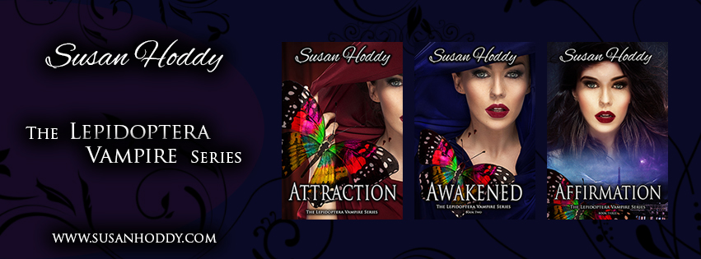

Hello and welcome to my July Newsletter.

It’s been an interesting month so far….

I am excited to announce that I have now released and self-published Awakened, which is the second book in The Lepidoptera Vampire Series. It’s available in E-Book and Paperback.

You can now buy *‘*Awakened’ at Dymocks, Collins Booksellers, Rockingham Books and all good bookshops. To get it right now, here are some links:

**Available from**

[**Amazon – E-Book**](https://www.amazon.com.au/d/Awakened-Lepidoptera-Vampire-Vampires-Book-ebook/B07211VFYB/ref=sr_1_1?ie=UTF8&qid=1499053001&sr=8-1&keywords=susan+hoddy)

[**Amazon - Paperback**](https://www.amazon.com/Awakened-Lepidoptera-Vampire-Susan-Hoddy/dp/0995413479/ref=tmm_pap_swatch_0?_encoding=UTF8&qid=1499053223&sr=8-1)

[**Susan Hoddy Website – E-Book & Paperback**](http://susanhoddy.com/books/)

[**Kobo – E-Book**](https://www.kobo.com/au/en/ebook/awakened-38)

[**Smashwords – E-Book**](https://www.smashwords.com/books/view/727432)

[**Barnes & Noble – E-Book & Paperback**](https://www.barnesandnoble.com/w/awakened-susan-hoddy/1126488290?ean=9780995413474)

Well, I am now at 48,246 words into the third book of the Lepidoptera Vampire Series. Continuing to write more each day. Most days I try to write between 8k – 10k. Should be ready for editing stage by end of July and then hopefully I should be able to publish it by November 2017. What do you think of the third book cover?

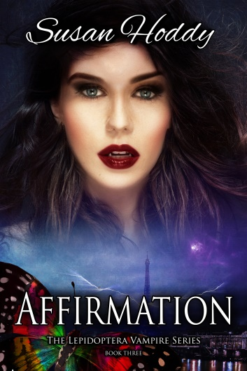

**Marketing My Books** - For the last two week I have been learning from some fellow colleagues how to market & promote my books via social media and the internet. It has been very interesting and informative what they have taught me and I have now put in place some plans which will make life a lot easier for me and free up my time. At lease I will be able to get back to what I really love, and that is writing.

A Big thank you to [Nick Stephenson](https://www.yourfirst10kreaders.com/) and [Derek Murphy](http://www.creativindie.com/) for their helpful videos/training.

My Albany Book Signing and Discussion went really well. I thoroughly enjoy chatting with everyone who came along. A big thank you to Deborah (Owner) and Suzanne for having me at [Dymocks Albany](https://www.dymocks.com.au/stores/wa/dymocks-albany). What a beautiful place Albany and the surrounding areas are. Haven’t been there for over twenty seven years, but I am sure we will be going back there again soon for some rest and relaxation. Some pictures below of the event.

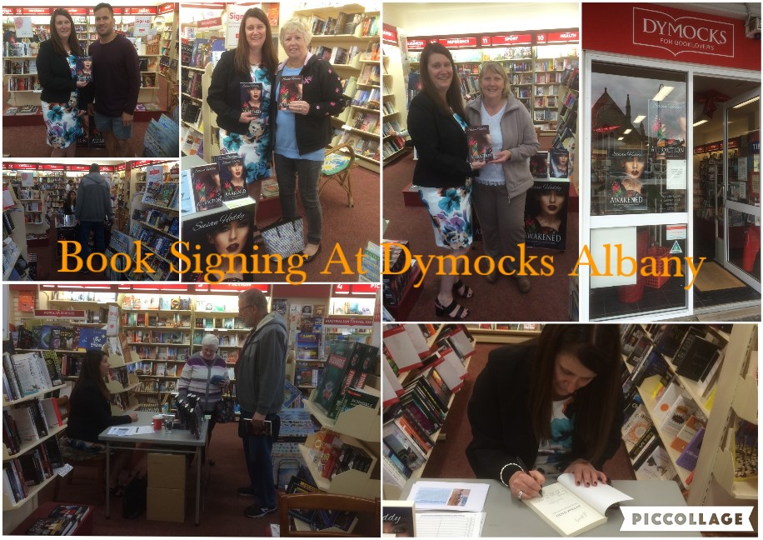

Last month I attended a brilliant workshop in Margaret River at the Regional Tafe which was about Self-Publishing in the Digital Age with the Ingram spark & Pickawoowoo. Was very informative and reiterated to me that I was on the right track with self-publishing my books. A Big Thank you to Debbie Lee from [Ingram Group Content](https://www.ingramcontent.com/) and Julie-Ann from [Pickawoowoo Publishing](https://www.pickawoowoo.com/). Thoroughly enjoyed the workshop and the [Readers & Writers festival](https://mrrwfestival.com/).

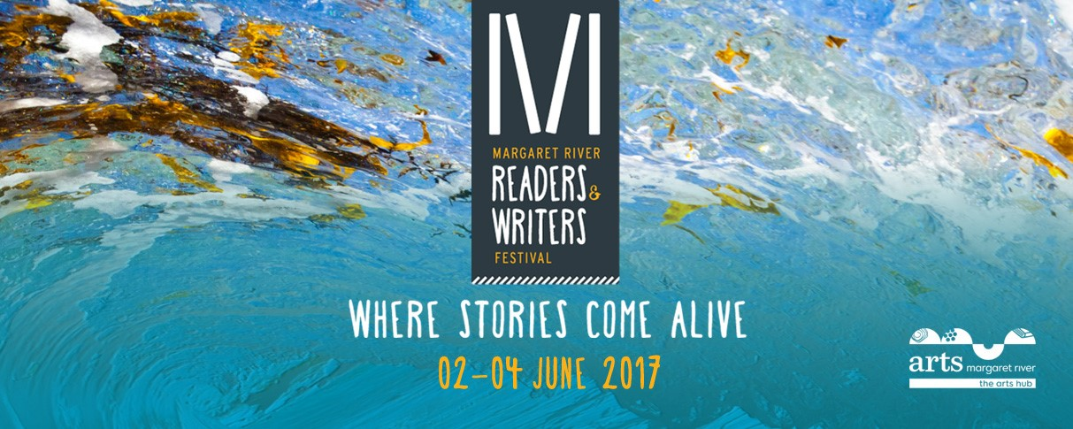

I had some disappointing news given to me the other day. My book cover designer has decided to retire for a while, so now I have been looking for someone else. I can’t believe how hard it has been to find a new book cover designer to create something I like, for my third book in the series. But the good news is today I have found a lovely lady from Mexico to help me design the next cover.

A Big Shout Out to Lily Violet – Love your work. She is such a great designer. Very patient and is always on time with her work. Would recommend her to anyone out there looking for a book cover designer. You can contact her via e-mail [winter.editorialdesign@gmail.com](mailto:winter.editorialdesign@gmail.com) or at [The Book Cover Designer](https://thebookcoverdesigner.com/designers/winter-editorial-design/)

Some of my readers have asked me how to pronounce Lepidoptera. Well here it is…

<https://www.youtube.com/watch?v=BD6S8InS0is>

For those of you that have read my first two books in the Lepidoptera Vampire Series; have you ever wondered what actually is a Lepidoptera and what does Bagnolet look like?

Website for information on what is a Lepidoptera

<https://en.wikipedia.org/wiki/Lepidoptera>

Have you ever wondered what Bagnolet in France looks like 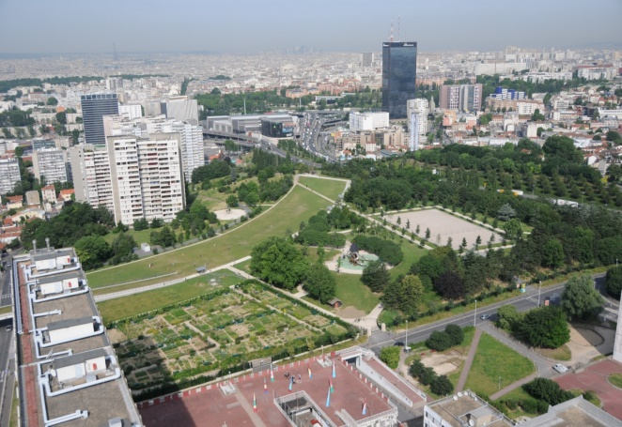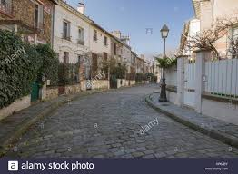

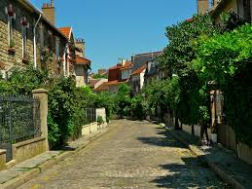

Information on Bagnolet, France.

<https://en.wikipedia.org/wiki/Bagnolet>

Where is Bagnolet?

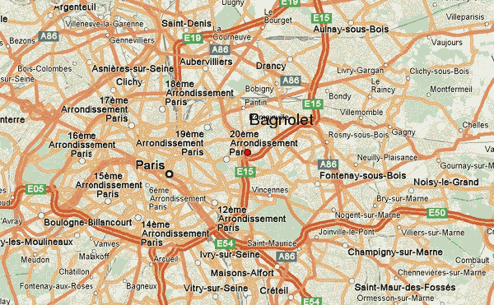

Feedback is good for authors – Is there something that you would like to see happen in the next book, or anything you don’t like or should be different in the first two books. Let me know, because I am always willing to listen to new ideas.

Have you ever been onto the Goodreads website? It’s a website where you can read & review literally thousands of books. Below is a link for you. Enjoy…

[http://www.MyAuthorBiz.com/accounts/laraadrian/images/goodreads-add-badge.png?v=1402397218332](https://www.goodreads.com/book/show)

## Ever thought of leaving a review?

If you love Susan Hoddy books, would you like to tell people about them? Visit [**Amazon**](https://www.amazon.com/s/ref=nb_sb_noss_1?url=search-alias%3Ddigital-text&field-keywords=susan+hoddy)or[**Goodreads**](http://www.goodreads.com/book/show/34307314-attraction) and write review/comment about my books. Positive or Negative. All opinions welcomed.

If you enjoyed reading my newsletter, please forward my e-mail to your work colleges, family and friends. Spread the word…

**Connect with me!**

|  |  |  |  |  |  |  |  |  |  |  |  |  |  |  |  |  |
| --- | --- | --- | --- | --- | --- | --- | --- | --- | --- | --- | --- | --- | --- | --- | --- | --- |
| |  |  |  |  |  |  |  |  |  |  |  |  |  |  |  |  | | --- | --- | --- | --- | --- | --- | --- | --- | --- | --- | --- | --- | --- | --- | --- | --- | | |  | | --- | | [Facebook](https://www.facebook.com/susan.hoddy) | | [Facebook](https://www.facebook.com/) | | |  | | --- | | [Instagram](https://www.instagram.com/susanhoddy/?hl=en) | | [Instagram](https://www.instagram.com/susanhoddy/?hl=en) | | |  | | --- | | [Pinterest](https://au.pinterest.com/susanhoddy/) | | [Pinterest](https://au.pinterest.com/susanhoddy/) | |  | |  | | --- | | [Twitter](https://twitter.com/susan_hoddy) | | [Twitter](https://twitter.com/susan_hoddy) | | |  | | --- | | [Website](http://susanhoddy.com/books/) | | [Website](http://susanhoddy.com/) | |   Susan Hoddy is an Australian, American and French young-adult fiction writer, best known for her Lepidoptera Vampire Series. Susan was born in Perth, Western Australia in 1966, and enjoys a good chinwag with family and friends, cups of tea, day-dreaming and writing. After acquiring her novel writing diploma from the Australian College of Journalism, she continues to create worlds where fantasy and romance exists, with her books. Keep an eye on her website [susanhoddy.com](http://susanhoddy.com) for more information about when the next book is coming out in November 2017.    **Free goodies for readers!**  C:\Users\hoddy\AppData\Local\Packages\Microsoft.Windows.Photos_8wekyb3d8bbwe\TempState\ShareCache\20170523_101608.jpg  I love to spoil my readers with bookmarks - free for the asking. Just send your request along with your **name, mailing address, and email address** to my website [susanhoddy.com](http://susanhoddy.com/contact-us-2/) and fill in the [Contact Us](http://susanhoddy.com/contact-us-2/) form. |



Copyright © 2017 Susan Hoddy. All rights reserved.

If you wish to unsubscribe to any further e-mails from me, just fill in the [Contact Us](http://susanhoddy.com/contact-us-2/) form

via my website [susanhoddy.com](http://susanhoddy.com/books/) and I will take you off my distribution list.