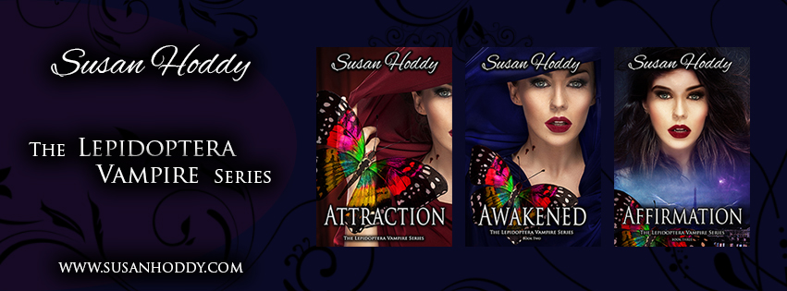

Hello and welcome to my September Newsletter.

Spring is here… thank goodness. I hope everyone has been able to escape the flu/head cold season so far.

I don’t know about anyone else, but for me, I am looking forward to some sunny days, where I can stand out in the sun and soak up the warmth. It always makes me feel alive.

As an author, I spend most of my days and some nights at my desk or in front of the computer, either researching, writing, editing, marketing etc. And every now and then I attend either some training to further my craft or speaking with potential readers about my books. But last week I was very fortunate to attend a network meeting with [The New Entrepreneurs](https://www.facebook.com/groups/TheNewEntrepreneurs/) who are like-minded people in small business, at the [Organic Café](https://www.organicproductsandhealthyfood.com.au/) in Victoria Park. I must say that I thoroughly enjoyed the topic that was discussed by guest speaker [Dave Cottam](http://davecottam.com/), on ‘Overcoming Ground Hog Day in your Network Marketing/Direct Sales Business’. Thank you for inviting me along to discuss my books and allowing me to promote my small, but expanding business as an author.

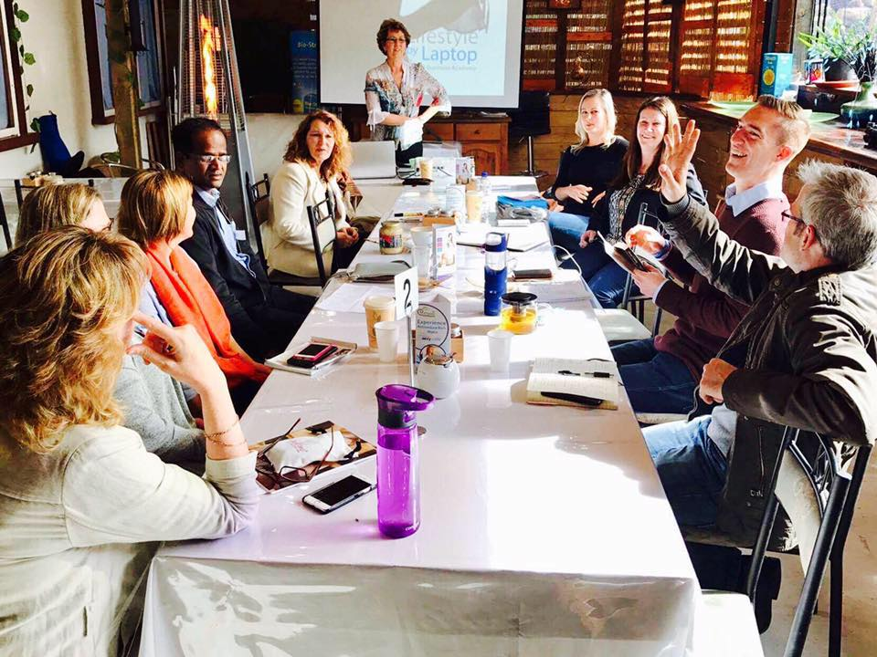

The next meeting with The New Entrepreneurs will be held on Friday 6th October and the guest speaker will be [Shirley McKinnon](https://parklanejewellery.com.au/rep/shirleymckinnon) , who is an author of three books and will be amongst other topics, providing information on how to achieve more success in your business. Please contact [The New Entrepreneurs](https://www.facebook.com/groups/TheNewEntrepreneurs/) if you would like to attend the next monthly meeting.

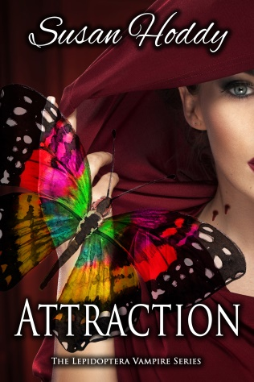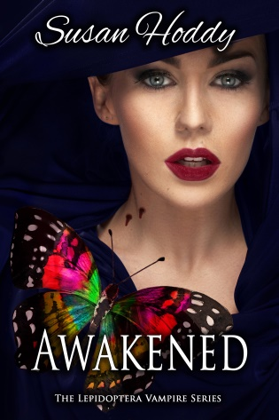

**Attraction & Awakened – The Lepidoptera Vampire Series**, which are the first two books in the series of five, were released earlier this year, and to say that I have been overwhelmed with the response I have received so far, is an understatement. Attraction & Awakened are now available worldwide, online and in all good book stores via E-Book and Paperback. I am most appreciative to all my readers out there for purchasing my books and I am thrilled that so many of you are enjoying the storyline so far.

Don’t forget you can always read a sneak peak of Chapter One from both books on my website [susanhoddy.com](http://susanhoddy.com/books/)

You can now buy ‘Attraction’ atDymocks, Collins Booksellers, Rockingham Books, Viva Books, Crow Books and all good bookshops. To get it right now, here are some links:

**Available from**

[**Amazon**](https://www.amazon.com.au/s/ref=nb_sb_noss?url=node%3D2496751051&field-keywords=susan+hoddy) **– E-Book**

[**Amazon**](https://www.amazon.com/Attraction-Lepidoptera-Ms-Susan-Hoddy/dp/0995413428/ref=tmm_pap_swatch_0?_encoding=UTF8&qid=&sr=) **- Paperback**

[**Booktopia**](http://www.booktopia.com.au/search.ep?keywords=susan+hoddy&productType=917504) **– Paperback & E-Book**

[**Susan Hoddy Website**](http://susanhoddy.com/books/) **– E-Book & Paperback**

[**Kobo**](https://www.kobo.com/au/en/search?Query=susan+hoddy) **– E-Book**

[**Smashwords**](https://www.smashwords.com/books/view/700682) **– E-Book**

[**Barnes & Noble**](http://www.barnesandnoble.com/s/susan+hoddy?_requestid=134529) **– E-Book & Paperback**

You can now buy *‘*Awakened’ atDymocks, Collins Booksellers, Rockingham Books, Viva Books, Crow Books and all good bookshops. To get it right now, here are some links:

**Available from**

[**Amazon – E-Book**](https://www.amazon.com.au/d/Awakened-Lepidoptera-Vampire-Vampires-Book-ebook/B07211VFYB/ref=sr_1_1?ie=UTF8&qid=1499053001&sr=8-1&keywords=susan+hoddy)

[**Amazon - Paperback**](https://www.amazon.com/Awakened-Lepidoptera-Vampire-Susan-Hoddy/dp/0995413479/ref=tmm_pap_swatch_0?_encoding=UTF8&qid=1499053223&sr=8-1)

[**Susan Hoddy Website – E-Book & Paperback**](http://susanhoddy.com/books/)

[**Kobo – E-Book**](https://www.kobo.com/au/en/ebook/awakened-38)

[**Smashwords – E-Book**](https://www.smashwords.com/books/view/727432)

[**Barnes & Noble – E-Book & Paperback**](https://www.barnesandnoble.com/w/awakened-susan-hoddy/1126488290?ean=9780995413474)

**If you are after a signed copy of my books, I do still have some available. Please fill in the** [**contact us**](http://susanhoddy.com/contact-us-2/) **form on my website** [**susanhoddy.com**](http://susanhoddy.com/books/) **. Anyone who purchases a signed copy from me will receive a free book mark as well. Postage is an additional cost.**

Also, if any libraries, book stores or book clubs would like me to come along and do a reading of some the chapters and/or a discussion about my books to their group of passionate readers, from either Attraction or Awakened, please don’t hesitate to contact me via my website and fill in the [contact us](http://susanhoddy.com/contact-us-2/) form. Readings/Discussions/Signings are done by appointment only.

I am excited to let you know that I have finally finished the first draft of Affirmation, which is the third book in the Lepidoptera Vampire Series. In some ways, this book was the hardest book for me to write. So many twists and turns and characters evolving. But even though it’s been hard, I have thoroughly enjoyed writing it.

Now down to something that I truly do love, besides writing of course; editing. I have just sent the first draft off to my editor in Albany and can’t wait to get started on the first lot of editing.

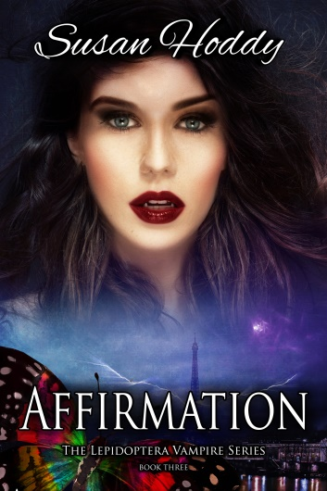

As a reader, have you ever wondered how much research goes into writing a book before the first draft is finished? If you have answered, Yes, then you are not alone. So many of my readers ask me that question, so I thought I would let you know about some of the research I had to do for my third book so far. Some days I spend hours researching the correct information so I can write this into the storyline. For instance, when I wanted to find out information on Switzerland’s surrounding rivers, mountains, buildings, houses, tourist attractions or what type of food, grain, etc are grown on farms and in what locations. I even remember one day I had to find out what type of barriers were placed on the edge of roads that have a steep drop into a mountain side, and whether it was wood or steel. Even down to trying to find out how far the distance is from one part of the country to another and how long it will take me to get there.

So, yes, my day is not only about writing and re-writing my storyline, I also need to do alot of research which then in turn goes into writing certain scenes etc in each book I write.

Google or U-Tube are sometimes your best friend when it comes to research, especially if you can’t visit some of the places you write about.

For my fellow authors… saw this on Facebook the other day… this cracked me up!

A writer died and was given the option of going to heaven or hell.  
She decided to check out each place first. As the writer descended into the fiery pits, she saw row upon row of writers chained to their desks in a steaming sweatshop. As they worked, they were repeatedly whipped with thorny lashes.  
"Oh my," said the writer. "Let me see heaven now."

A few moments later, as she ascended into heaven, she saw rows of writers, chained to their desks in a steaming sweatshop. As they worked, they, too, were whipped with thorny lashes.  
"Wait a minute," said the writer. "This is just as bad as hell!"  
"Oh no, it's not," replied an unseen voice. "Here, your work gets published."

**Feedback is good for authors** – Is there something that you would like to see happen in the next book, or anything you don’t like or should be different in the first two books. Let me know, because I am always willing to listen to new ideas. Please log onto my website [susanhoddy.com](http://susanhoddy.com/books/) and fill in the [contact us](http://susanhoddy.com/contact-us-2/) form.

Have you ever been onto the Goodreads website? It’s a website where you can read & review literally thousands of books. Below is a link for you. Enjoy…

[http://www.MyAuthorBiz.com/accounts/laraadrian/images/goodreads-add-badge.png?v=1402397218332](https://www.goodreads.com/book/show)

|  |  |  |  |  |  |  |  |  |  |  |  |  |  |  |  |  |
| --- | --- | --- | --- | --- | --- | --- | --- | --- | --- | --- | --- | --- | --- | --- | --- | --- |
| **Ever thought of leaving a review?**  If you love Susan Hoddy books, and would you like to tell people about them? Visit [**Amazon**](https://www.amazon.com/s/ref=nb_sb_noss_1?url=search-alias%3Ddigital-text&field-keywords=susan+hoddy)or[**Goodreads**](http://www.goodreads.com/book/show/34307314-attraction) and write review/comment about my books. Positive or Negative. All opinions welcomed.  Susan Hoddy is an Australian, American and French young-adult fiction writer, best known for her Lepidoptera Vampire Series. Susan was born in Perth, Western Australia in 1966, and enjoys a good chinwag with family and friends, cups of tea, day-dreaming and writing. After acquiring her novel writing diploma from the Australian College of Journalism, she continues to create worlds where fantasy and romance exists, with her books. Keep an eye on her website [susanhoddy.com](http://susanhoddy.com) for more information about when the next book is coming out in November 2017.    **Free goodies for readers!**  C:\Users\hoddy\AppData\Local\Packages\Microsoft.Windows.Photos_8wekyb3d8bbwe\TempState\ShareCache\20170523_101608.jpg  I love to spoil my readers with bookmarks - free for the asking. Just send your request along with your **name, mailing address, and email address** to my website [susanhoddy.com](http://susanhoddy.com/contact-us-2/) and fill in the [Contact Us](http://susanhoddy.com/contact-us-2/) form.  **If you enjoyed reading my newsletter, please forward my e-mail to your work colleges, family and friends. I am only too happy if they would like to be added to my mailing list each month. Spread the word…**  **Connect with me!**   |  |  |  |  |  |  |  |  |  |  |  |  |  |  |  |  | | --- | --- | --- | --- | --- | --- | --- | --- | --- | --- | --- | --- | --- | --- | --- | --- | | |  | | --- | | [Facebook](https://www.facebook.com/susanhoddyauthor) | | [Facebook](https://www.facebook.com/susanhoddyauthor/) | | |  | | --- | | [Instagram](https://www.instagram.com/susanhoddy/?hl=en) | | [Instagram](https://www.instagram.com/susanhoddy/?hl=en) | | |  | | --- | | [Pinterest](https://au.pinterest.com/susanhoddy/) | | [Pinterest](https://au.pinterest.com/susanhoddy/) | |  | |  | | --- | | [Twitter](https://twitter.com/susan_hoddy) | | [Twitter](https://twitter.com/susan_hoddy) | | |  | | --- | | [Website](http://susanhoddy.com/books/) | | [Website](http://susanhoddy.com/) | |     Copyright © 2017 Susan Hoddy. All rights reserved.  If you wish to unsubscribe to any further e-mails from me, just fill in the [Contact Us](http://susanhoddy.com/contact-us-2/) form  via my website [susanhoddy.com](http://susanhoddy.com/books/) and I will take you off my distribution list. |
|  |
|  |